Having the XSLT in KMC is a powerful feature.

However, this is still incomplete, since every publisher account has a different schema to his metadata structure, video flavors available, etc.

To that extent, publishers also need the ability to download the FULL schema XML (what’s available through KalturaGenericSyndicationFeed) and some high-level instructions guiding the publisher what to do in-order to create his own feed types using XSLT.

In addition, the “XSL Code” field is redundant and confusing, since it is not editable and not even useful.

**Original -**

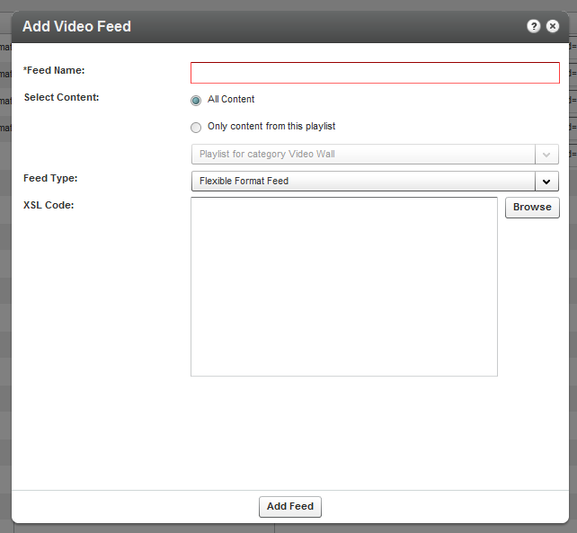

**New suggested Flexible Feed UI -**



Often, it is required to have custom made xml feeds to suit integrations or ingest content from your Kaltura account into various platforms. Kaltura’s Flexible Feed provides a mean to translate the Kaltura metadata into any desired XML format using XSLT (Learn more about XML Transformations).

To create your own feed, download the Kaltura Generic Syndication Feed XML, and follow the following guide to create your own XSLT. Then upload your XSLT here and click “Add Feed”.

1. Download your account’s **Generic Syndication Feed**.
2. Follow the **Kaltura Feed XSLT Creation guide** and create your XSLT file.
3. Selected XSLT File: **No file chosen yet.**